Roll No. .......................................
CHEM2414T: Polymers and Surface Chemistry
Maximum Marks: 70 Time Allowed: 3 Hrs.
Note: Attempt two questions (out of four) each from Section A and Section B, carrying 12 marks each, and the entire Section C, consisting of 11 short questions carrying 2 marks each.
Section A
Q1 (a) Discuss the kinetics of self-catalyzed step polymerization and derive the rate equation showing it follows third-order kinetics. 8
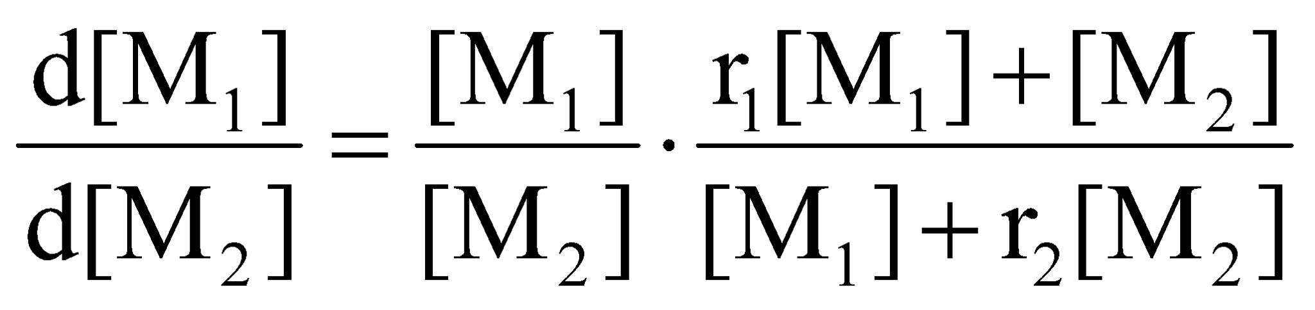
(b) Explain the working of redox initiators with the help of suitable examples. 4
Q2 (a) Show that for co-polymers. 6

(b) Explain the kinetics of initiation in radical chain polymerization. 6
Q3 (a) Discuss emulsion polymerization in detail, highlighting its mechanism, advantages, and kinetics. 7
(b) What is the difference between step and chain polymerization 5
4 (a) Describe how polymer molecular weight is determined using the Sedimentation Equilibrium method. 7
(b) Explain the concept of Molecular Weight Distribution (MWD) in polymers using a neat diagram. 5
Section B
Q5 (a) Derive the Brunauer-Emmett-Teller (BET) adsorption equation and explain how it is utilized for the estimation of the surface area of an adsorbent. 8
(b) Describe the different types of adsorption isotherms observed during the adsorption of gases on solids. 4
6 (a) Discuss the kinetics of heterogeneous bimolecular reactions on solid surfaces where both gases are adsorbed. 8
(b) How is catalytic activity determined experimentally? Explain. 4
7 (a) Explain the principle, working, and application of Auger Electron Spectroscopy (AES) in surface chemistry. 7
(b) Explain the phenomenon of wetting and define the contact angle. 5
8 (a) Discuss the effect of nature of adsorbed gases and the nature of the adsorbent on the magnitude of gas adsorption. 6
(b) Define surface tension and explain how surfactants alter the surface tension of water. 6
Section C
Q9 Attempt all Questions:
- Define viscosity average molecular weight.
- What is the reactivity of functional groups principle in step polymerization?
- Name two types of initiators used in radical chain polymerization.
- Define interfacial tension.
- What is a surfactant?
- State the criteria of catalysis.
- Why do polymers not show a sharp melting point?
- Define unimolecular layers in adsorption.
- What is a linear polymer?
- Define catalytic activity.
- What is functionality?
(11 x 2 = 22)
Roll No. .......................................
CHEM2414T: Polymers and Surface Chemistry
Maximum Marks: 70 Time Allowed: 3 Hrs.
Note: Attempt two questions (out of four) each from Section A and Section B, carrying 12 marks each, and the entire Section C, consisting of 11 short questions carrying 2 marks each.
Section A
Q1 (a) Discuss the kinetics of self-catalyzed step polymerization and derive the rate equation showing it follows third-order kinetics. 8
(b) Explain the working of redox initiators with the help of suitable examples. 4
Q2 (a) Show that for co-polymers. 6

(b) Explain the kinetics of initiation in radical chain polymerization. 6
Q3 (a) Discuss emulsion polymerization in detail, highlighting its mechanism, advantages, and kinetics. 7
(b) What is the difference between step and chain polymerization 5
4 (a) Describe how polymer molecular weight is determined using the Sedimentation Equilibrium method. 7
(b) Explain the concept of Molecular Weight Distribution (MWD) in polymers using a neat diagram. 5
Section B
Q5 (a) Derive the Brunauer-Emmett-Teller (BET) adsorption equation and explain how it is utilized for the estimation of the surface area of an adsorbent. 8
(b) Describe the different types of adsorption isotherms observed during the adsorption of gases on solids. 4
6 (a) Discuss the kinetics of heterogeneous bimolecular reactions on solid surfaces where both gases are adsorbed. 8
(b) How is catalytic activity determined experimentally? Explain. 4
7 (a) Explain the principle, working, and application of Auger Electron Spectroscopy (AES) in surface chemistry. 7
(b) Explain the phenomenon of wetting and define the contact angle. 5
8 (a) Discuss the effect of nature of adsorbed gases and the nature of the adsorbent on the magnitude of gas adsorption. 6
(b) Define surface tension and explain how surfactants alter the surface tension of water. 6
Section C
Q9 Attempt all Questions:
- Define viscosity average molecular weight.
- What is the reactivity of functional groups principle in step polymerization?
- Name two types of initiators used in radical chain polymerization.
- Define interfacial tension.
- What is a surfactant?
- State the criteria of catalysis.
- Why do polymers not show a sharp melting point?
- Define unimolecular layers in adsorption.
- What is a linear polymer?
- Define catalytic activity.
- What is functionality?
(11 x 2 = 22)

